Reporting aggregated Data using Group Function
- Find the highest, lowest, sum, and average salary of all employees. Label the columns.
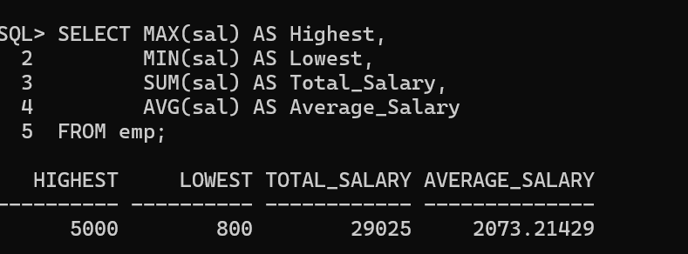

- Display Maximum, Minimum, Sum, and Average salary. Round the results to the nearest whole number.
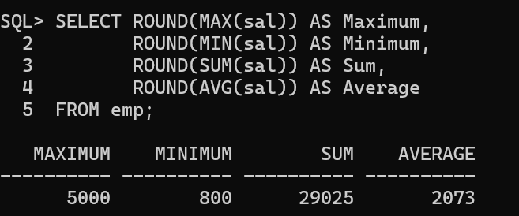

- Display the minimum, maximum, sum, and average salary for each job type.
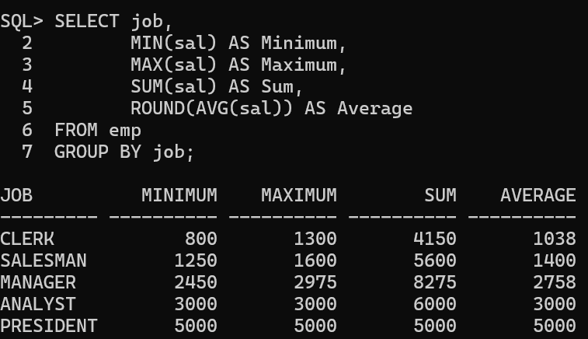

- Display the number of people with the same job.

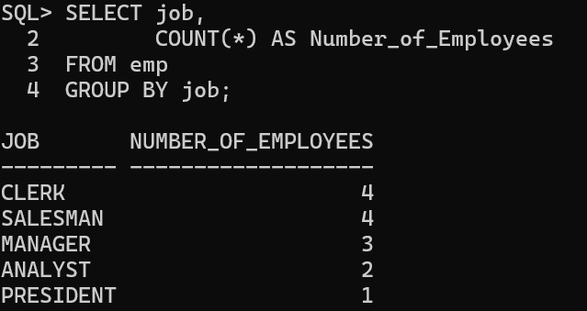

- Determine the number of managers without listing them. Label the column Number of Managers.
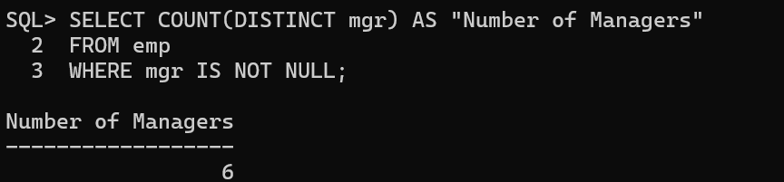

- Find the difference between the highest and lowest salaries. Label the column DIFFERENCE.
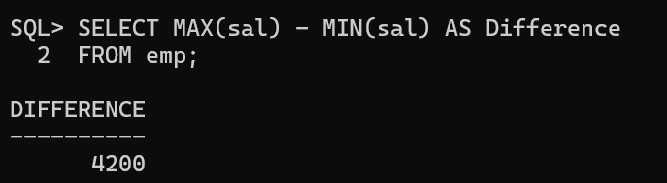

- Display the manager number and the salary of the lowest-paid employee for that manager.
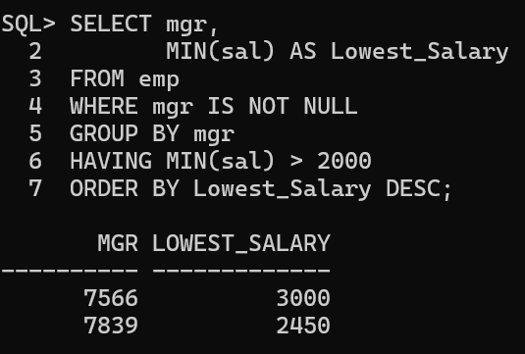

- Display the total number of employees and the number hired in 1980, 1981, and 1982.
